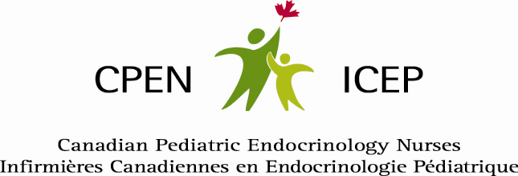

Video Resource: Giving Solu-Cortef Injections
Click on the link: https://vimeo.com/729190005/b33d4fc742
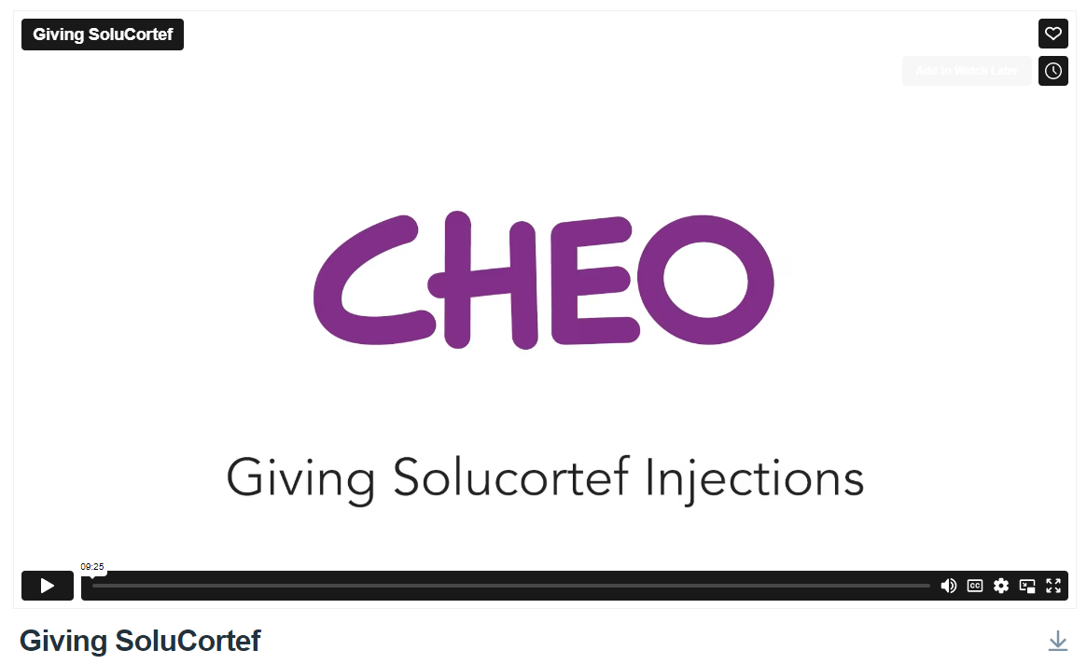

Thank you to Ms. Brenda Fraser, Canadian Pediatric Endocrine Nurse at the Children’s Hospital of Eastern Ontario (CHEO), and her patient and family actors for developing and sharing this video resource.

